**INVENTION DISCLOSURE FORM**

Date of Submission of Form for patent processing: 02-Mar-2021

**Client Information**

**Contact Person :**

**Address :**

**Telephone/ mobile :**

**Fax :**

**E-mail :**

**Applicant Details**

**Full Name : Suyash Singh**

**Address :**

**Nationality :**

**Inventor(s) Details**

***(Please list the inventors in the order their names will appear on the patent)***

**Name :**

**Citizenship :**

**Mailing Address :**

**Contact Number :**

**E-mail :**

**Name :**

**Citizenship :**

**Mailing Address :**

**Contact Number :**

**E-mail :**

**Name :**

**Citizenship :**

**Mailing Address :**

**Contact Number :**

**E-mail :**

**Name :**

**Citizenship :**

**Mailing Address :**

**Contact Number :**

**E-mail :**

**Name :**

**Citizenship :**

**Mailing Address :**

**Contact Number :**

**E-mail :**

1. **INVENTION DISCLOSURE**
2. **Provide a Descriptive Title of Invention.**

Sensor system onboard an aircraft or spacecraft capable of generating a new dataset

1. **Provide a list of relevant known prior art documents (patents, published articles, etc.). Please only indicate documents already known to the inventors. A separate search need not be done to fill in this field.**

None

1. **Provide a brief summary of the existent art/state of the art and its limitations. Also indicate what problem(s) does the invention solve?**

The art in this case refers to the technologies in place, for Earth Observation & Remote Sensing. Currently, there are two sensors that are largely used to get details about the object being sensed.

* Optical – Multispectral/Hyperspectral Sensor

This is a passive sensor, requiring an external source of radiation, like the sunlight, to be able to acquire data. As a result, they can acquire data only during day time, over areas that do not have a significant cloud cover. Given a global average cloud cover of at least 50% any time of the year, an Optical sensor can acquire data only during clear day, and not cloud day, clear night or cloudy night, thus allowing only for 25% usage of the potential. Working in the Visible & Infrared region of the EM Spectrum, they can sense color of the object being sensed, and some infrared-based properties. However, they are insensitive to geometry of the object.

* Microwave - Radar Sensor

This is an active sensor, sending its own radiation and capturing it back, instead of depending on an external source of radiation, like the sunlight. As a result, they can acquire data irrespective of the time of day and weather, not being blocked by clouds. While working in the Microwave region of the EM Spectrum, they can sense the returning waves, which vary based on the geometry of the object being sensed. Another key point about this sensor is that they are insensitive to color, and only return values that fall in a fixed range, and can be relatively plotted on a common scale.

Understanding the arts in the industry, the limitations have also been explained in the above paragraphs. A lot of research has been done on comparing these two datasets. Diving deeper into the comparison and the sensor properties, there is growing adaptation of seeing these two datasets more as complementary than competing datasets. As a result, this has triggered a new field of Data Fusion and Co-registration of both these datasets, to extract further insights. Broadly, there are three levels of fusing both the sensor data – Decision-level, Feature-level and Pixel-level. Decision-level Fusion treats both these as distinct datasets, and performs individual processing, just combining the final insights from both of these, at the report level. This is more like a macro level of fusion, not focusing on a lot of details. Feature-level Fusion combines pixels in each of these datasets individually, and then fuse the features and objects such as object area, edges, etc. This compromises on minute details in the individual datasets. In pixel-level fusion, Raw data of both these sensors are co-registered and fused to generated a data cube, and thus, a completely new “fused” dataset. This is proven to be the most accurate form of Data Fusion in terms of the data being used and extracted.

The current problem occurs when trying to approach Pixel-level data fusion. Today, the raw data acquired for both the sensors come from distinct sources, each of them having their own technical specifications and parameters. Further, given how differently both the sensors operate, it is challenging to co-register these datasets, when obtained from different sources, thus leading to a lot of errors. As a result, the overall process, as of today, consumes a lot of time and efforts, while still being limited in terms of the accuracy obtained, as a result of the Data Fusion.

1. **Provide Description of the Invention and its technical implementation. (Please feel free to attach additional sheets / documents to elaborate)**

A sensor system on board an aircraft or a spacecraft which is capable of generating a new data set as a result of pixel level co-registration of individual sensor data. The sensor system collects data in the visible, Infrared and microwave region of the EM spectrum.

**Description of sensor system**:  The sensor system consists of visible and Infrared sensors along with microwave sensors onboard an aircraft or spacecraft. It also consists of a synchronizer unit which ensures the required alignment of all the sensors in order to capture spatially and temporally matched datasets. These datasets are then processed onboard to produce an enriched pixel level co-registered data.

**Synchroniser**: The unit should ensure the following during sensing operation:

1. **Same look angles for the visible, IR and the Microwave sensors**: This implies that the orientation of all the imaging receivers (such as telescope, antenna) and transmitters (such as antenna) should remain same with respect to satellite **(Fig. 1)**
2. **Beamwidth of the microwave sensor should be same as Field of View of optical sensor in the range direction**. This ensures a common width of the sensed area
3. The sensors should start seeing the area of interest simultaneously.
4. No of pixels in visible + infrared dataset should be a whole number multiple of number of pixels in the microwave dataset.
5. Time stamp of azimuth elements should match across the datasets.

 The synchroniser unit consists of the following components:

* Motion sensors
* Actuators
* Controlling Unit

The Motion sensors detect the change in orientation of the visible, infrared and the microwave sensors and inputs this feedback to the controlling unit which then triggers the actuators to re-initialize the desired orientation of these sensors. This feedback mechanism ensures (1) and (2) **(Fig. 5)** The controlling unit also has a common clock with control logic to ensures (3) and (4).

**The interconnected network of Sensor System**

1. The synchronizer unit should be connected to the main sensing elements of the system as well as with the stabilizing unit of the airborne or spaceborne vehicle.
2. The controlling unit takes feedback from the secondary sensors to ensure (1) and (2) I.e., aligning the transmitting and receiving elements of the sensor **(Fig. 5)**. The controlling unit should also provide all inputs required by multiple components at different times in the system (such as time stamp) which ensures (3). It will also adjust various sensing parameters (such as PRF, time of operation, etc) depending on the requirement of the operation, ensuring (4) and (5) **(Fig. 6)**.

**Co-registration**

The rationale of co-registration is to ensure that the images become spatially aligned so that any feature in one image overlaps with the same feature in the other image the pre-processing steps are carried out onboard in order to refine the data to the extent necessary for co-registration. The output is a co-registered image with a sub-pixel level accuracy. Please refer to**Fig. 4** for the detailed illustration of this process.

1. **Please provide representative figures/diagrams of the Invention.**

***(Please provide/enclose labeled figures/diagrams including graphs, tables, circuit diagrams, simulation results, flow charts, chemical formulae, equations, sketches, rough artwork, penciled graphs, etc., which are satisfactorily clear to help in understanding the invention.)***

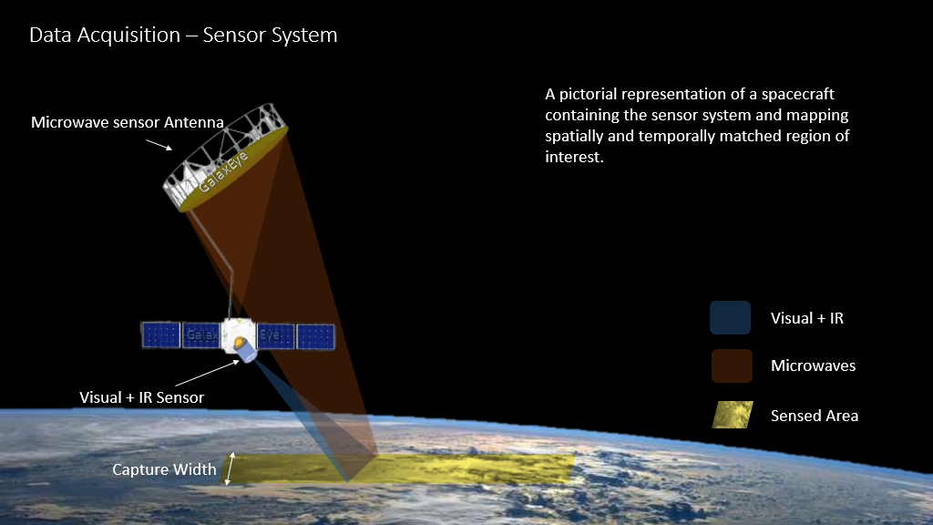

**Fig 1:** Working principle of the sensor system

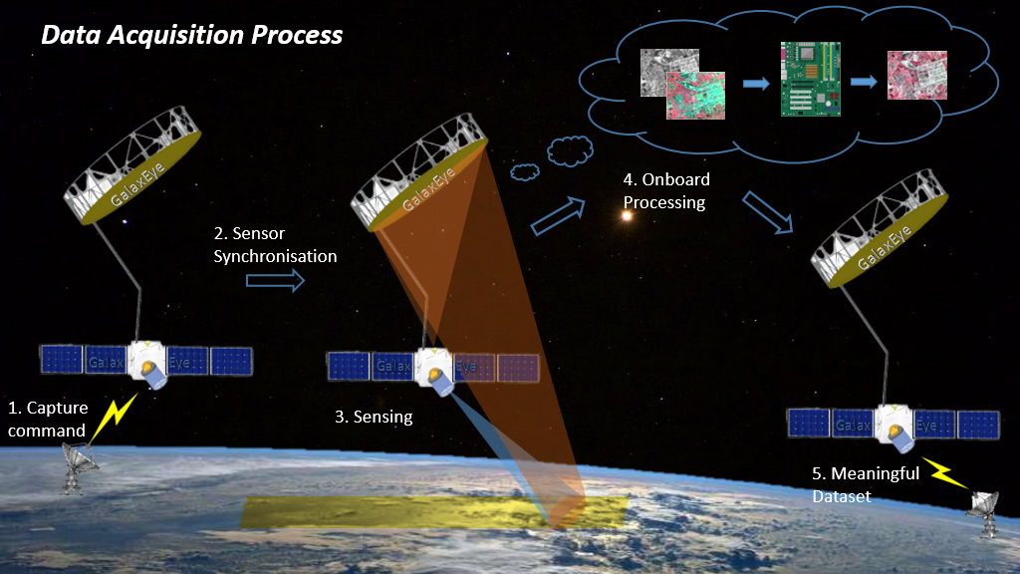   
**Fig 2:** Data Acquisition process of the Sensor System

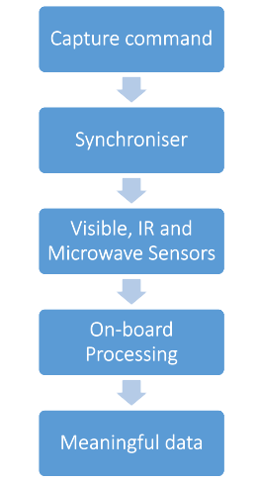

**Fig 3:** Data Acquisition process of the Sensor System

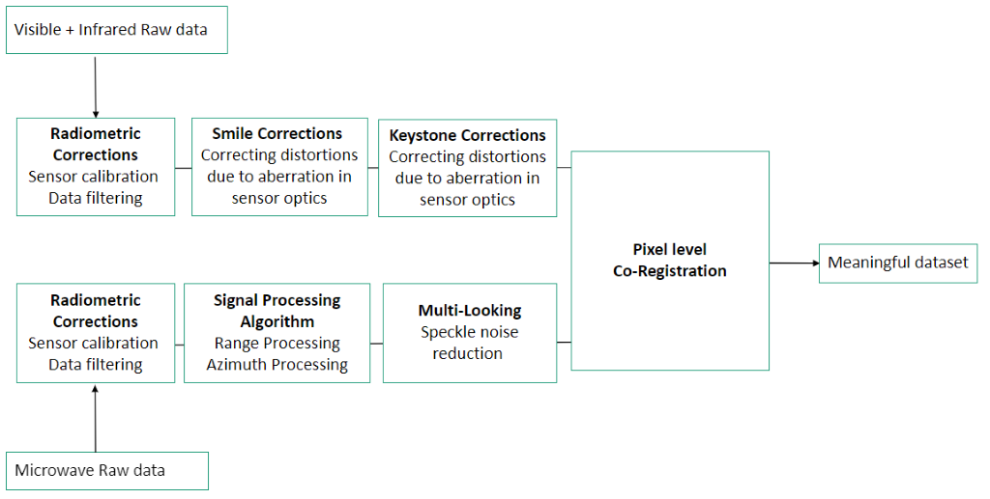

**Fig 4:** Flow diagram of the Co-registration process using RAW Visible, IR and Microwave data

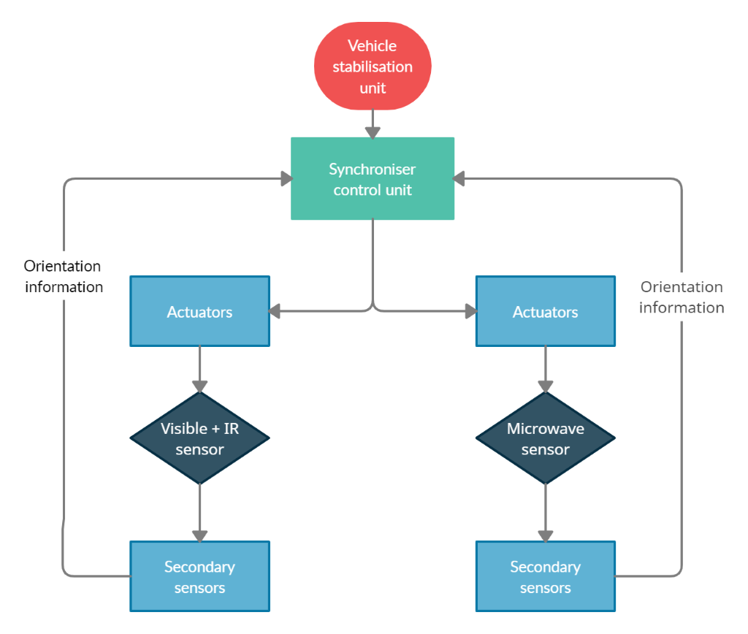

**Fig 5:** Synchroniser Feedback Mechanism

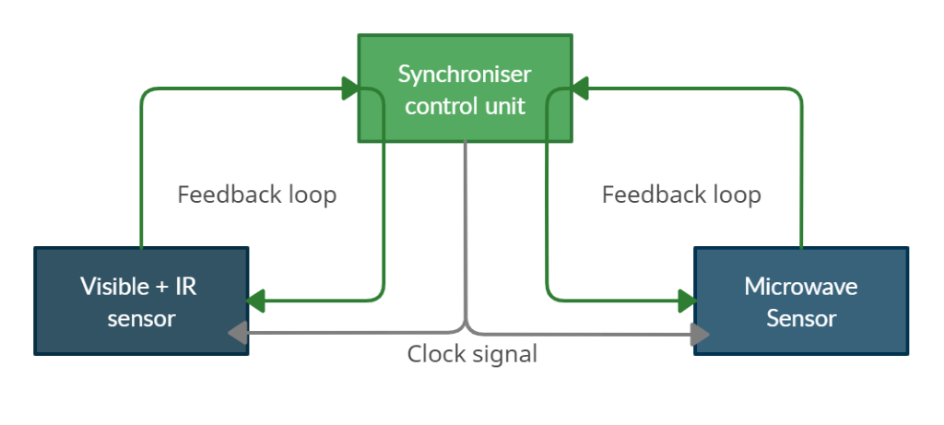

**Fig 6**: Controlling sensing parameters and clock

1. **Provide a brief summary of points of novelty in the invention, as per the inventor.**
2. Spatially and temporally matched data sets from visible-IR and microwave sensors at a raw level onboard our platform

* The synchroniser of the sensor system ensures that RAW sensor data is captured with an equal spatial width. It also ensures that all the sensors are working at the same clock and are triggered at the same time. This ensures that the datasets are spatially and temporally matched.

1. Generating pixel level co-registered dataset on board our satellite platform
   * + The pre-processing is carried out on the spatially and temporally matched RAW data to produce pixel level co-registered dataset
2. **Provide advantages of the Invention.**

* This invention would generate a totally new kind of dataset, that would be a result of pixel-level co-registration of individual sensor data, obtained from a sensor system. It takes advantage of the complementary nature of the individual sensors, and combines best of the both the worlds.
* Housing the individual sensors in a common system allows for data acquisition by them over the same place, “at the same time”. This is currently not possible as the individual sensor datasets currently come from different sources. As a result, the integrity and consistency of the datasets are maintained.
* Given the complementary nature of the individual sensors, the newly generated dataset merges value additions from each of the sensors, and thus, is richer in information as compared to any of them individually.
* This newly generated dataset would also improve the accuracy of Deep Learning Algorithms as we would now have a much richer database, which would be a result of pixel-level co-registration of individual sensor data.
* As we know that Optical sensor cannot sense through clouds, a lot of the acquired data becomes meaningless, due to the existent loud cover in the data acquired. Typically, any dataset with over 10% cloud cover is not used for data processing, analytics and insights. Using Radar sensor, which can acquire data even during cloudy weather, this threshold can be pushed further, thus increasing the potential of dealing with higher cloud cover. As a result, the amount of meaningful data being captured increases significantly.
* This system covers a wider range of bands on the Electromagnetic spectrum, for data acquisition, as compared to any other system in place as of this date.

1. **If not indicated previously, indicate what are possible uses/ applications for the invention? Does it enhance the usefulness of an existing technology? In addition to immediate applications, are there other uses that might be realized in future?**

There are various applications that leverage Earth Observation and Remote Sensing. They can broadly be classified into three use cases – Asset Detection, Asset Monitoring (Inspection/Tracking), Change Detection. These can be applied to various industries, including but not limited to Agriculture, Real Estate, Utilities, Defence, Finance, Supply Chain, Mining, Infrastructure, etc. While Optical data is widely used for visual understanding of the Area of interest, Radar data helps unlock deeper insights that would not be possible to obtain from Optical data. This new dataset can be used to capture both color and geometry of the objects being sensed, thus giving better perspective of the Area of interest.

* In case of agriculture, the newly generated dataset will be able to point out the type of soil (eg. Color) and also the moisture content of the soil, thus helping plan the fertilization and irrigation pattern.
* Another application is in forest mapping, where this new dataset can help monitor the forestry type (shape of trees) and vegetation health (based on color of leaves), thus track level of deforestation.
* Given the limitation of Optical Sensor being able to generate colored imagery, only during clear day time, this new dataset will be able to generate colored imagery even during night time, due to data acquisition using the Radar sensor, which is part of the sensor system.
* This new dataset can also prove beneficial in mapping camouflaged objects, which is a limitation with Optical Sensor. In most cases, Radar sensor can point out abnormalities in the area, despite camouflage, but not exactly explain much about the object. A real time example is from Africa, where the water management system in rural settlement areas was planned based on this application. The residences were a mix of houses with roofs made of metal sheet, and those made of thatched grass. The latter camouflaged with the ground, but the former was picked up by the Radar sensor. Having picked these points, a detailed acquisition using Optical sensor over these areas gave an idea about the population and the area covered. This saved a lot of time, money and efforts, as compared to doing a manual ground check over the areas.
* Radar sensors also have the capability to detect underground water levels. This new dataset would thus be able to give a visual map of the area, with the underground water levels at that specific location. Doing this today, with data obtained from different sources would come with a lot of errors and complexity, as already explained earlier.

1. **PRIOR DISCLOSURE INFORMATION**

1. **Have any patent applications been filed by you, which are closely related to the Invention? If yes, please provide publication number.**

None

1. **Has any product been designed/ launched which incorporates the invention? If yes, please provide details to determine novelty.**

None

1. **Are you planning any disclosure of the Invention/ launch of product implementing the invention in near future? If yes, please provide approximate dates and locations.**

Yes. We are targeting to complete the product development by January 2022 and Testing of the Product by February 2022. The location for this will be Chennai, India.

The product, as is being used here, refers to a common synchronized sensor system, acquiring data from high altitudes, which can then be used for processing and analytics, to gather insights from the data.

**------------------------------Thank You -----------------------------------**